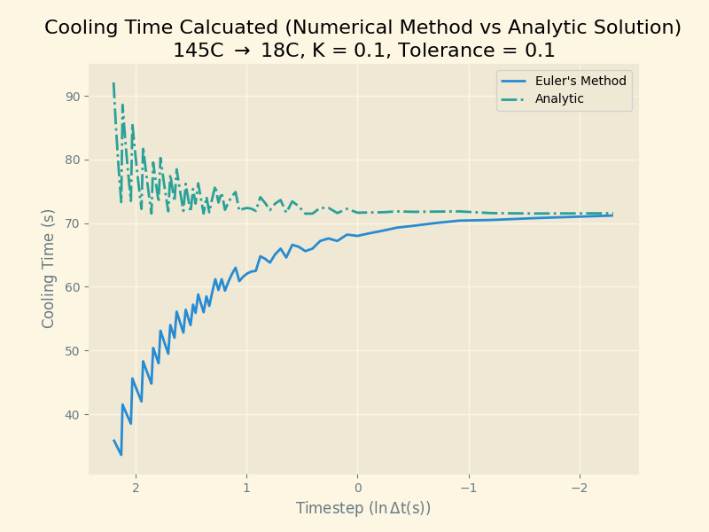
Figure 1. Cooling Times for a Simulated Cup of Coffee. Cooling times were calculated analytically and estimated via a numerical method (Euler's Method).
As shown in Figure 1, we see that the difference between the analytic and numerically derived cooling times approach one another as time step decreases. The ‘final’ temperature used in the analytic solution was the final estimated temperature in the numerical estimation. The final numerical estimated temperature approaches the true temperature and time as the timestep becomes smaller.

